December Writing Sample- Due on December 12

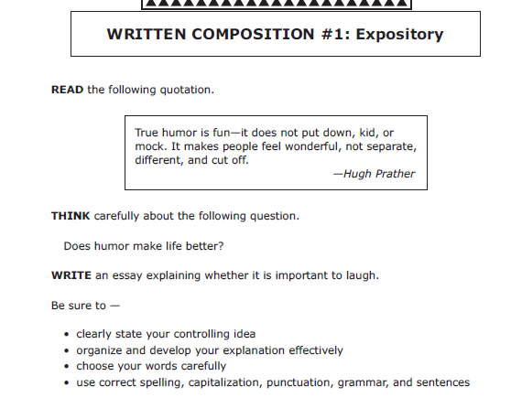
This is our December writing sample. It will be due to your homeroom teacher on December 12. We will go over the topic and how to write for that topic in a recording that will be sent out on December 3. You will need to use the lined composition paper on which to write your paper. You will need to write neatly and make sure to go through all steps of the writing process. Once you have finished your paper you will scan it to your homeroom teacher. This MUST be completed by December 12 at 5 p.m. You will also be responsible for Quiz Star questions as well.

