Wonderful Families,

Welcome to K12 Texas. We are excited to have you join our program. Together we will work to achieve educational greatness. In addition to testing, class connects, and progress, K12 Texas also measures academic growth through work samples and student-teacher communication and collaboration. Student completed work samples and student-teacher communication work sample grades will be assigned a grade monthly. We will use QuizStar as part of our monthly work samples for STAAR tested subjects, and we will send each family a kmail that includes a work sample for Non-STAAR tested subjects. Work samples will be focused on work your student is studying (if your student is on track) and communication between your homeroom teacher and student. Work samples will count as 10-20% of each student’s quarterly report card grade in each subject. You will be able to locate your work sample grades in the gradebook once your teacher grades your samples or documents your student’s active participation in student-teacher communication.

Student-teacher communication based work samples will be assigned a participation grade (100 or 0) monthly. Participation can occur in Data Conferences, Monday Morning Meetings, kmails, check in calls, tutoring, etc.

Work samples that are to be completed by the student will be kmailed by your homeroom teacher at the beginning of the work sample window. Your student will have from Monday the week the sample is received until Friday at 5pm the second week to complete all work samples on their list. QuizStar work samples will need to be completed the first week and Non-STAAR work samples will be turned in the second week. STAAR tested subjects will require students to answer questions on QuizStar website. Non-STAAR tested subjects will require a student to submit a document, picture, or project to their homeroom teacher. This means the student will have to show proof of their work monthly to send to their homeroom teacher. Students may share a word document, send a picture from their camera or phone, or scan a document that shows their work. Students who fail to turn in their work will receive a 0 on that assignment.

Here is the rubric for grading:

Exceeds
(100-90% for session/Tasks)
Meets
89-80% for session/Tasks)
Approaches
(79-70% for session/Tasks)
Fails Far Below
(69-0% for session/Tasks)

Updated Timeline for Work Samples:

QuizStar Work Sample assignments for the year will be given: | Non-STAAR Work Sample assignments for the year will be given:
9/26 to 10/3: | 9/26 to 10/3:
10/31-11/7 | No Non-STAAR samples this month
12/1-12/5 | 12/1-12/12
No QS this month | 1/5/1/9
1/26-1/30 | 1/26 to 2/6
3/2-3/6 | 3/2-3/13
4/6-4/10 | 4/6-4/17
4/27-5/1 | 4/27-5/8

Logging into Quiz Star

Each student has an account in QuizStar. The username is the student’s first name followed by their student id number.

Example: Joshua123456

The password is k12texas.

QuizStar is located at the following web address:

http://quizstar.4teachers.org/indexs.jsp

Students should use their login information to enter the site.

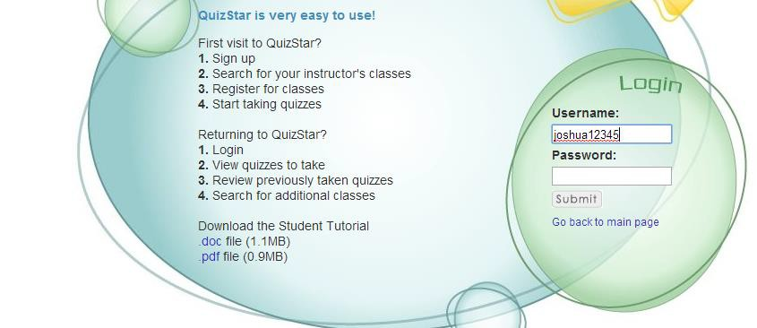

Once the student is logged in to the site they will be able to access their assigned quizzes.

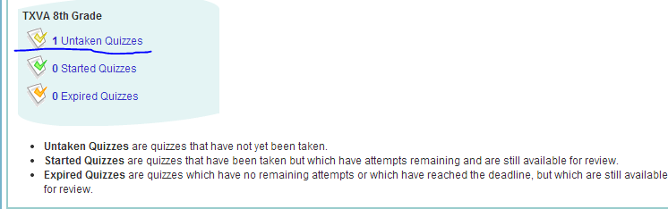

Students will only get one attempt on each test in QuizStar. Please let your students know that they will need to take their time and complete the quiz to the best of their ability on the first attempt. Please do not start a quiz unless you know you have the time to complete it as quizzes cannot be saved. If a student moves rapidly through the quiz, it will spoil the quiz. Students are encouraged to take their time when completing their QuizStar assignment.

If you have any issues with logging on to QuizStar, please contact your homeroom teacher immediately.

We are so glad to have you with us this year. Thank you for partnering with us to help your student grow academically.

Sincerely, K12 Texas

